**Vi Editor**

1. **Invoke the vi editor with a filename (which is to be created)**

**Ans:vi file 8.txt->Go to insert mode ->enter text->:wq(In cmd mod to save and exit)->cat file6.txt**

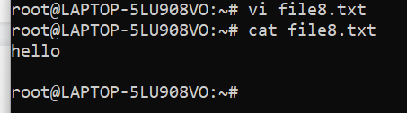

**2.Type a few lines(at least 10) in the editor. Let one or more lines contain the words given below.**

**delhi mumbai chennai Mumbai**

**Ans:**

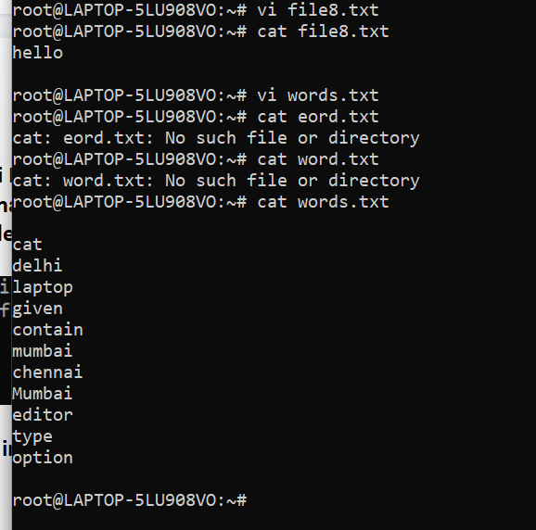

**3.Save the file without exiting the editor**

**Ans: :w**

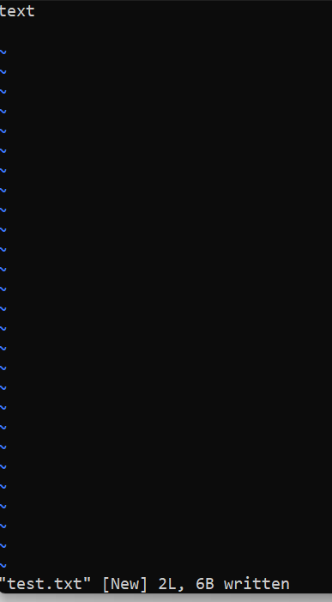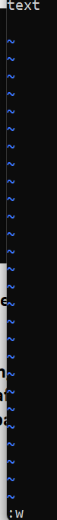

1. **Navigate quickly to the beginning & end of the file**

**Ans: Beginnig of the file:**Go to command mode->press gg

**End of the file:**Go to command mode->press shift + g

1. **Delete first two lines & copy it after the last line.**

**Ans:** 2dd - delete first two, G-go to last line, $-to go to end of last line , p-paste after the cursor

1. **Now Copy the last two lines & paste them before the first line.**

**Ans:**yy-to copy last two lines from the cursor, g-go to first line, P-paste it before cursor

1. **Combine last two lines of the file in a single line.**

**Ans:** J

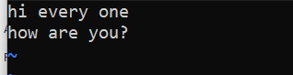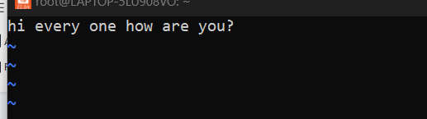

1. **How will you insert a line before the first line? (Hint : Find such an option in the tutorial document)**

**Ans:** sed '0 a\

**9.How will you paste a yanked buffer before the current line?**

**Ans: yy->P**

1. **Search the document for a string “delhi”**

**Ans:** In normal mode(command mode), you can search forward or backward.

One can search forward in vim/vi by pressing / and then typing your search pattern/word.

To search backward in vi/vim by pressing ? and then typing your search pattern/word.

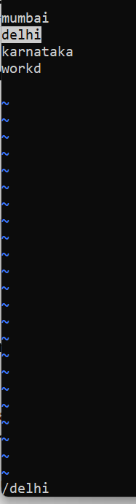

1. **Replace a single occurrence of “delhi” with “Mumbai”**

**Ans: :%s/delhi/Mumbai/g**

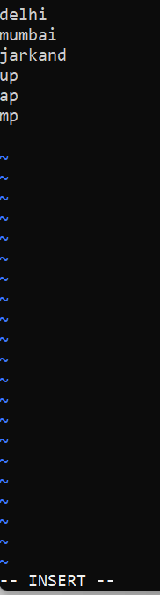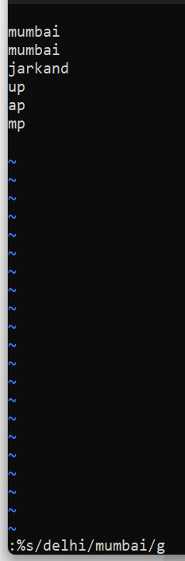

1. **Replace all occurrences of “delhi” on a particular line with “Mumbai” using one command**

**Ans: :1s/delhi/Mumbai/g (1 indicates particular line)**

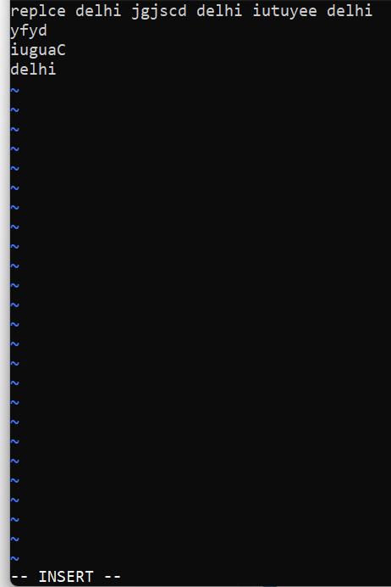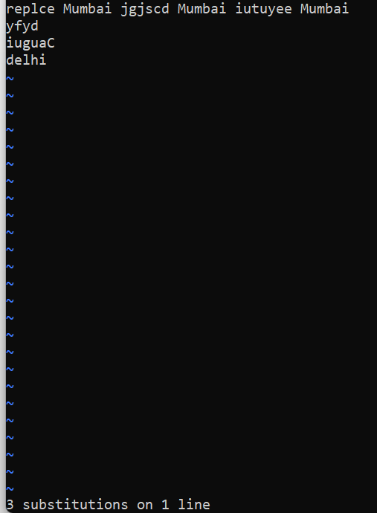

**13.Replace “delhi” with “mumbai” for the entire document using one command.**

**Ans:** :%s/delhi/mumbai/gc->press y->enter

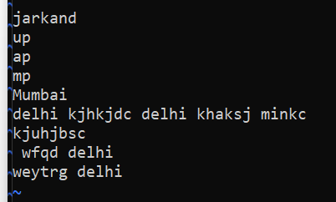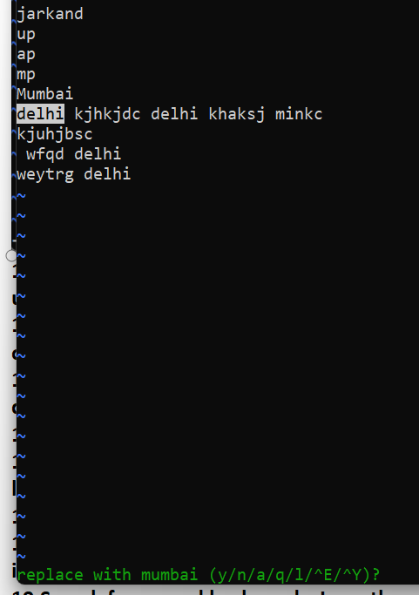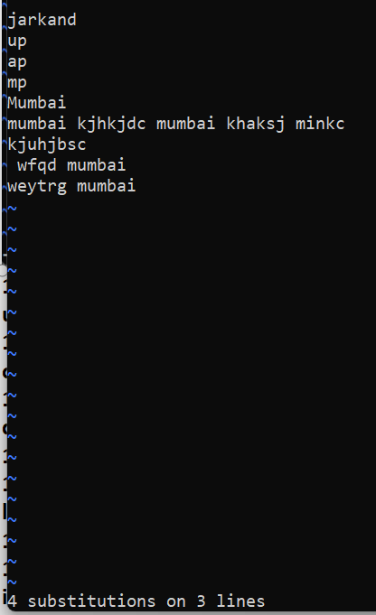

1. **Replace all occurrences of “delhi” with “mumbai” for part of a document (e.g. line number 13 to 37).**

**Ans: :13,37s/delhi/mumbai/g**

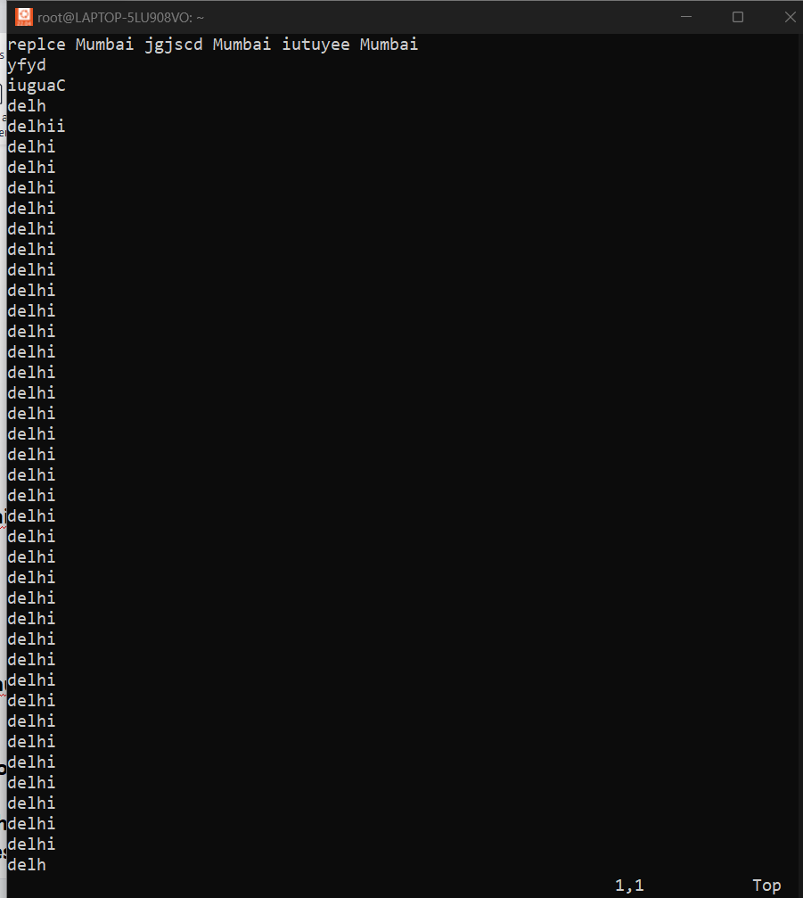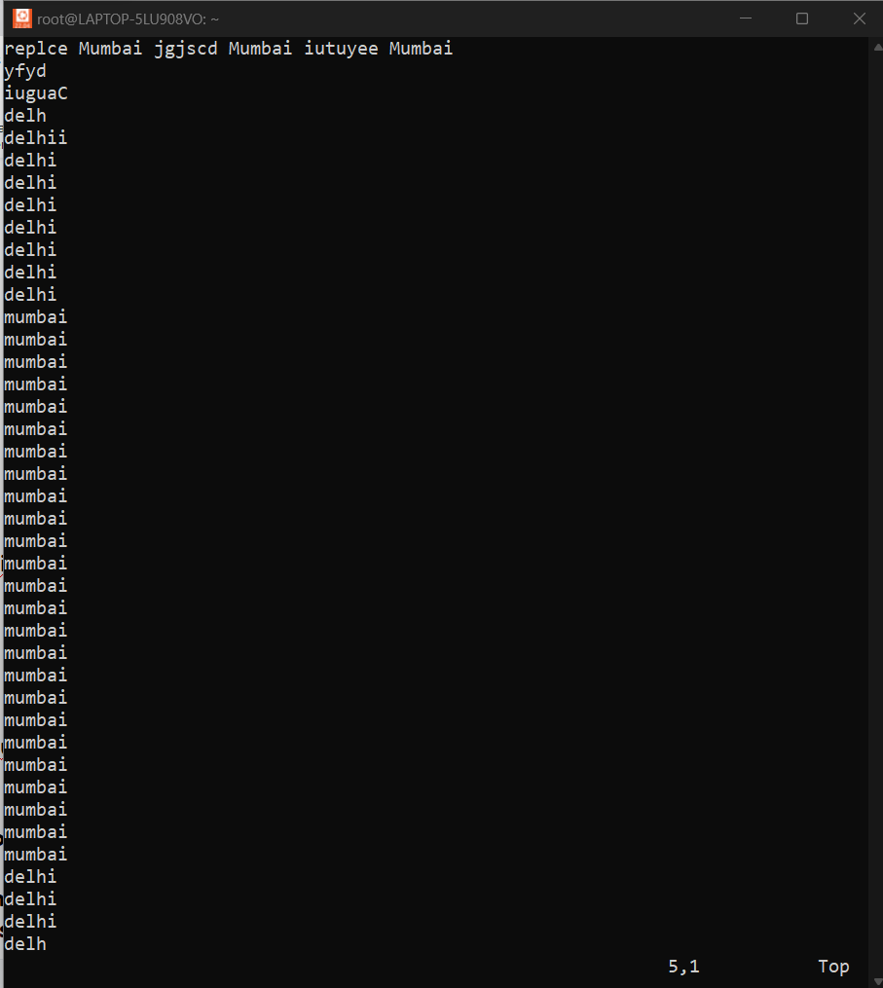

1. **Undo the above command**

**:Ans:** :u



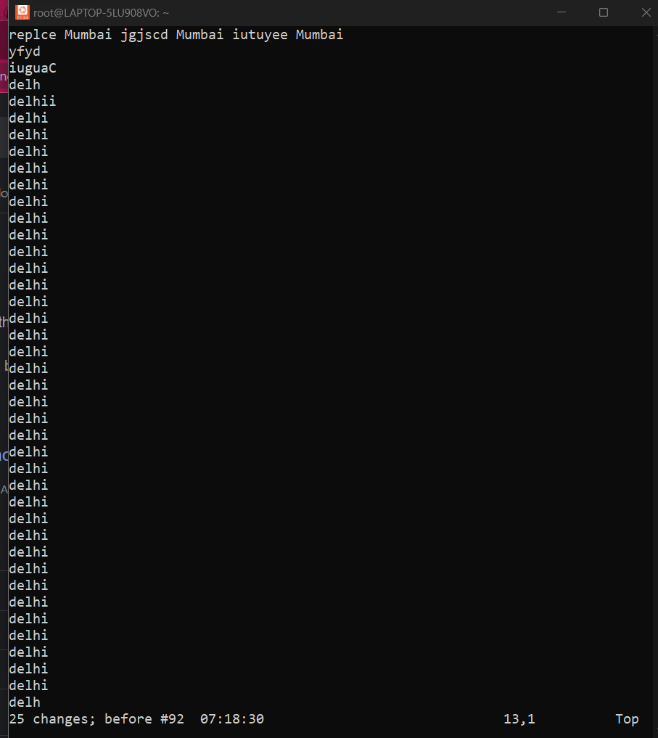

1. **Replace only the first occurrence of “delhi” with “mumbai” in each line, for part of a document (e.g. line number 13 to 37).**

**Ans: :13,37s/delhi/mumbai/g**





1. **Undo the above comment. Redo it. Undo it again.**

**Ans:** Press the Esc key to go back to the normal mode. ESC.

Type u to undo the last change.

To undo the two last changes, you would type 2u .

Press Ctrl-r to redo changes which were undone. In other words, undo the undos. Typically, known as redo.

**(or)** u ctrl+R u

1. **Replace all occurrences of “delhi” with “mumbai” for complete file interactively.**

**Ans:** :%s/delhi/Mumbai/gc and a

1. **Search for a word backwards. Loop through all matches.**

**Ans:** One can search forward in vim/vi by pressing / and then typing your search pattern/word. To search backward in vi/vim by **pressing ? and then typing your search pattern/word**. Once word found in vim, you can press the n key to go directly to the next occurrence of the word in backwards. **/delhi**

1. **Search for a word forwards. Loop through all matches**

**Ans:** In normal mode you can search forwards by **pressing / (or <kDivide> ) then typing your search pattern**. Press Esc to cancel or press Enter to perform the search. Then press n to search forwards for the next occurrence, or N to search backwards. **?delhi**

1. **Join two lines together.**

**Ans:** When you want to merge two lines into one, **position the cursor anywhere on the first line, and press J to join the two lines**. J joins the line the cursor is on with the line below. Repeat the last command ( J ) with the . to join the next line with the current line.

**J**

**22.Enable line numbering and then disable it**

**Ans: Enable:** :set number

**Diable:** :set nonumber

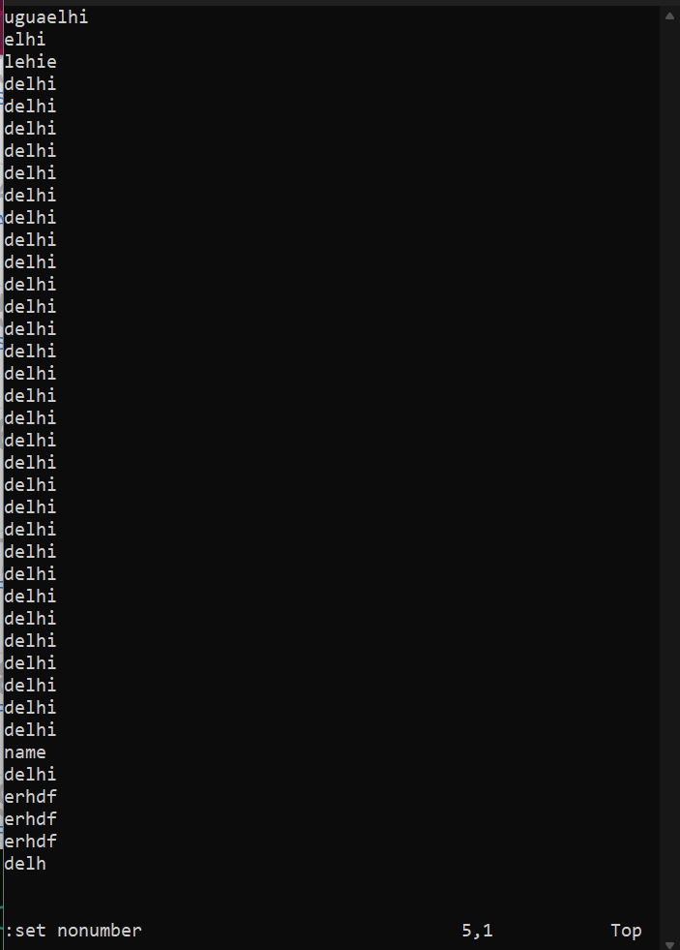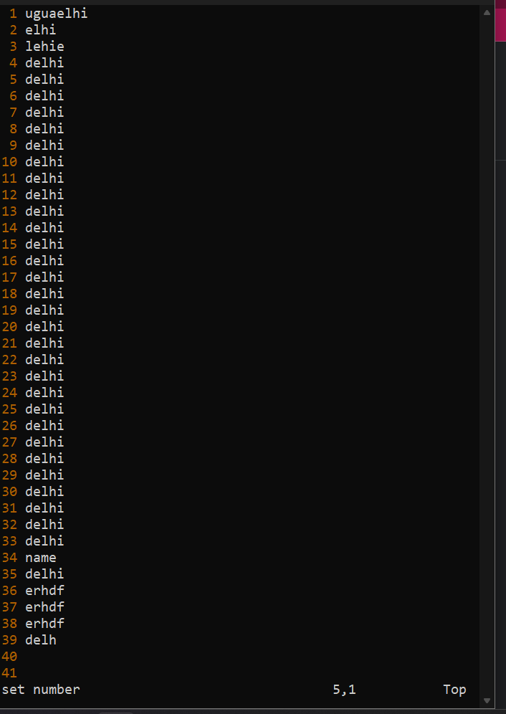

**23.Make the search case insensitive**

**Ans:** Searches normally are case-sensitive: a search for "china" will not find "China." If you want vi to ignore case during a search, **type :set ic** . To change it back to the default, case-sensitive mode, type :set noic .

**24.Delete 4 lines (and then paste them somewhere else)**

**Ans:** Press v to select characters, or uppercase V to select whole lines, or Ctrl-v to select rectangular blocks (use Ctrl-q if Ctrl-v is mapped to paste). Move the cursor to the end of what you want to cut. Press d to cut (or y to copy). Move to where you would like to paste. **4dd and P**

**25.What is the command to delete part of the line starting from the current cursor position?**

**Ans: d$**

**26.What is the command to delete the current word?**

**Ans:** In Vi Editor go to command mode. Type **dw** to delete current word